Gender Mainstreaming in Disaster Risk Reduction (DRR): Initiative by Zone4solutions

Introduction to the term Gender
Gender refers to the socially constructed roles, responsibilities, opportunities, and power relations associated with women and men, girls and boys, within a given socio-cultural context. These roles and relationships are dynamic, context-specific, and subject to change over time. Gender influences access to resources, decision-making, and participation across all sectors, including Disaster Risk Reduction (DRR). It is important to note that gender does not refer exclusively to women; however, given the persistent structural inequalities that disproportionately disadvantage women, gender-responsive policies must prioritize women’s empowerment while promoting equitable participation and benefits for all. Integrating gender perspectives into policy and planning is essential to ensure inclusive, effective, and sustainable development outcomes.

Gender and Disaster
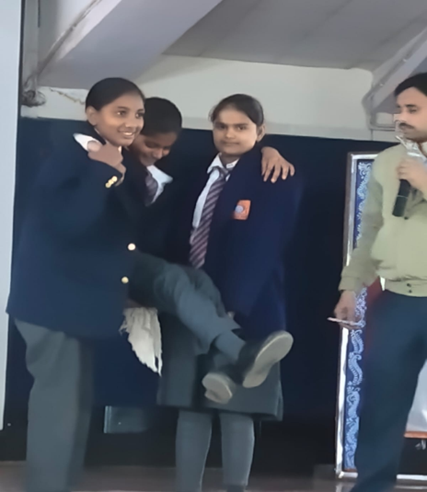
Disasters affect women, men, girls, and boys differently, with impacts shaped by age, socio-economic status, and existing gender inequalities. These differences influence both vulnerability to hazards and the capacity to respond to and recover from disasters. In contexts where gender discrimination persists, women and girls often face heightened risks, including higher mortality rates and increased exposure to gender-based violence such as domestic abuse, trafficking, and exploitation during and after disasters.
Women and girls also bear a disproportionate burden of unpaid care work, including responsibilities related to water, food, and household management, which intensify during disaster situations. Additionally, sectors where women are highly represented—such as agriculture and informal livelihoods—are particularly vulnerable to climate and disaster-related risks.
Gender inequality continues to be one of the most persistent global challenges, cutting across all sectors of development. Although progress has been made—such as improvements in girls’ school enrolment—significant gaps remain in economic participation, legal rights, and political representation. These systemic inequalities directly influence disaster risk and resilience. Achieving gender equality is not only a fundamental human right but also a prerequisite for sustainable and inclusive development. In below Figure -1 it is illustrated that how gender dynamics support in Disaster Risk Reduction: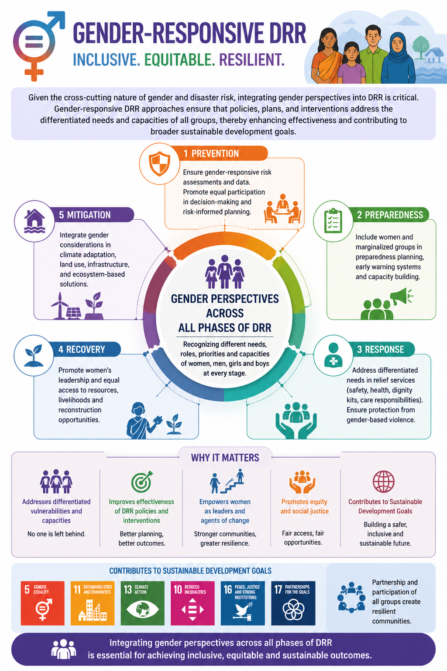
Given the cross-cutting nature of gender and disaster risk, integrating gender perspectives into DRR is critical. Gender-responsive DRR approaches ensure that policies, plans, and interventions address the differentiated needs and capacities of all groups, thereby enhancing effectiveness and contributing to broader sustainable development goals. Therefore, integrating gender perspectives across all phases of Disaster Risk Reduction (DRR) is essential for achieving inclusive, equitable, and sustainable outcomes.

Gender Equality and DRR-Global Commitments
DRR is a vital pillar for sustainable development and works on the principle of ‘Society Inclusive Approach’. Consistent advocacy over the last few decades has resulted in increasing acknowledgement of the constructive role of women in disaster risk reduction. This notion differs from traditional opinions that women and girls as inherently vulnerable and hence are passive recipients of development and humanitarian assistance. DRR’s focus on addressing the underlying causes of risks and vulnerabilities is an entry point for recognizing root causes and structural constraints of gender inequality and for targeting those in the promotion of transformative and sustainable change. Unequal power relations between women and men and pervasive gender stereotypes are among those structural constraints. Addressing them will contribute to enhancing women’s rights, participation and leadership in prevention and reduction of disaster risk at all levels.The international community has dedicated to gender equality and women’s rights in disaster risk reduction. These commitments are documented in the Convention on the Elimination of All Forms of Discrimination against Women (CEDAW), the Beijing Declaration and Platform for Action, the Sendai Framework for Action and CSW resolutions (56/2 and 58/2) on gender equality and the empowerment of women in disasters, Paris Agreement. It has been observed that Gender equality and women’s empowerment are keys to the success of all post-2015 multilateral agendas, including 2030 Agenda, the Paris Agreement, the Sendai Framework, and all future actions on reducing climatic and disaster risk.
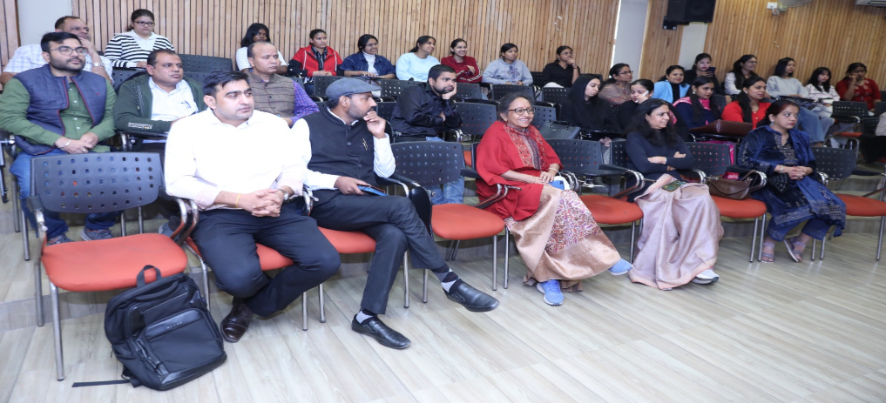
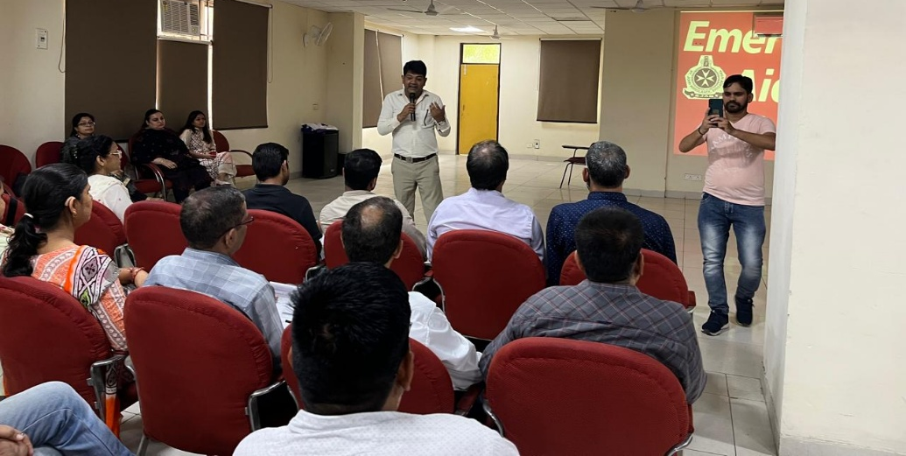

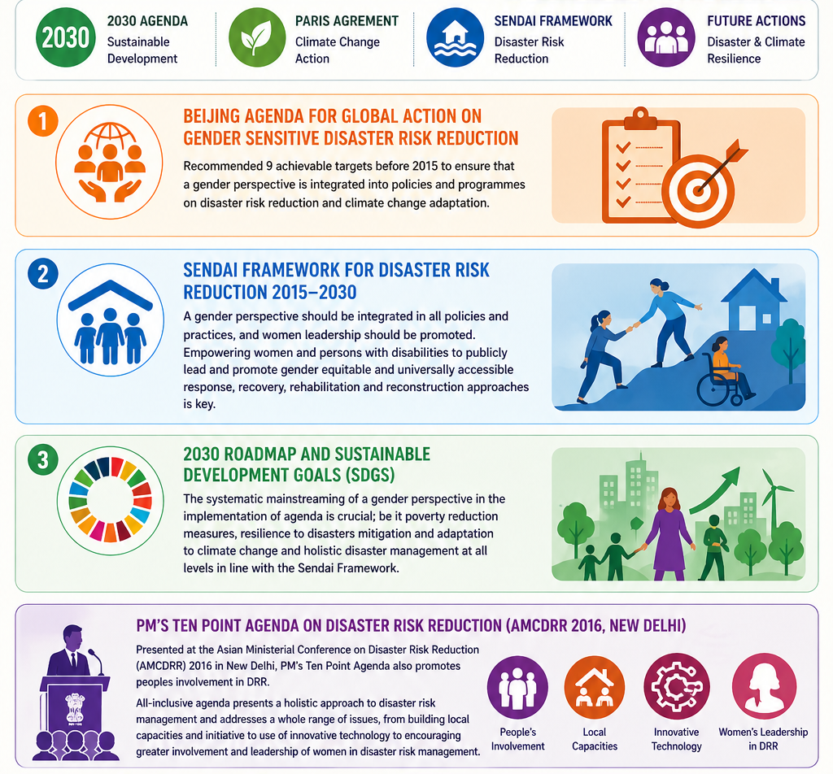
2030 Roadmap and SDGs – The systematic mainstreaming of a gender perspective in the implementation of agenda is crucial; be it poverty reduction measures, resilience to disasters mitigation and adaptation to climate change and holistic disaster management at all levels in line with the Sendai Framework.
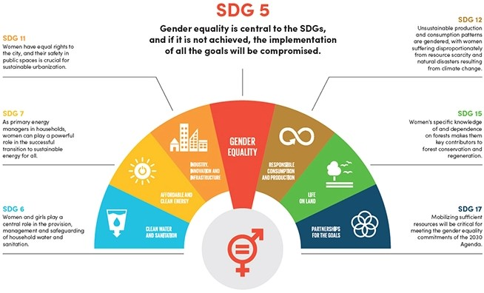

Initiative by Zone4solutions
Zone 4 Disaster Solutions Pvt. Ltd. (Zone4Solutions) is an ISO-certified disaster management services company with proven expertise in addressing the dual challenges of hazard and risk through comprehensive and cost-effective solutions tailored for Indian organizations. The organization adopts an inclusive approach to Disaster Risk Reduction (DRR), with a strong emphasis on mainstreaming vulnerable groups such as women, children, and persons with disabilities into resilience-building processes. With a vision to contribute to a disaster-resilient India, Zone4Solutions offers a wide range of services including disaster management planning, school and university safety, community-based preparedness, climate change adaptation, risk governance, socio-economic analysis, capacity building, and knowledge management.
Over the years, Zone4Solutions has partnered with more than 300 organizations—including corporates, institutions, schools, and hospitality sectors—across India to develop customized Disaster Management Plans and strengthen community awareness. A notable achievement includes organizing India’s largest school evacuation drill, recognized by the Limca Book of Records. As part of its gender mainstreaming initiatives, the organization has developed Disaster Management Plans for women’s colleges under Delhi University and conducted targeted training programmes and mock drills. During the COVID-19 pandemic, it also organized an international webinar on gender mainstreaming in DRR, which received wide appreciation from diverse stakeholders.

The organization’s gender-focused interventions aim to strengthen inclusive disaster governance through:
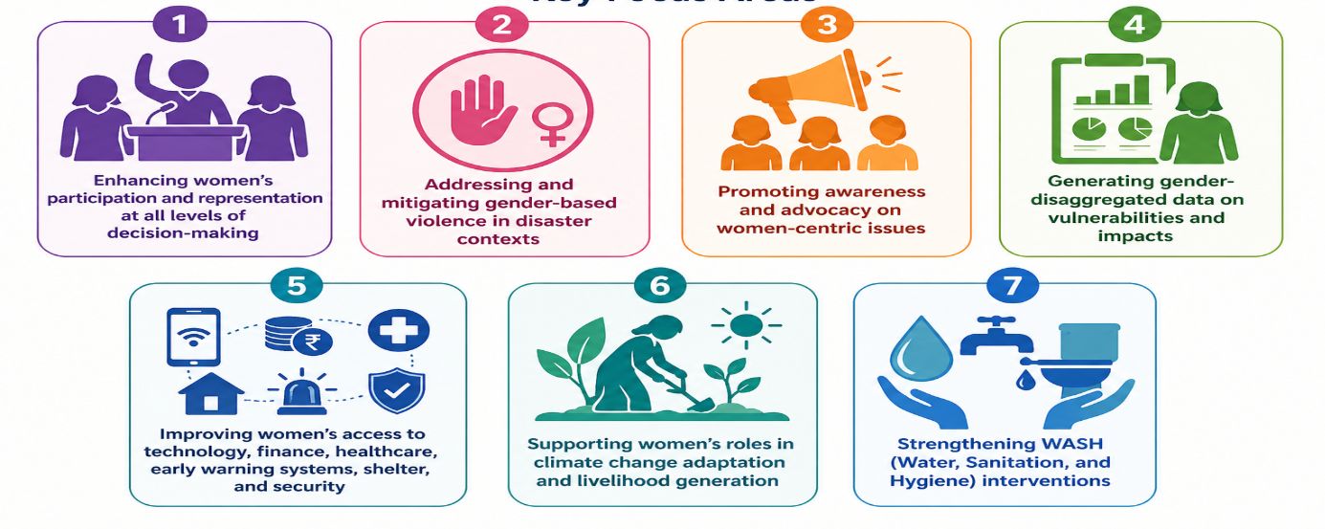
Through these efforts, Zone4Solutions reinforces the critical role of gender-responsive approaches in building inclusive, resilient, and sustainable communities.

Case Studies

30 hours Skill development training, Aditi Mahavidyalaya, University of Delhi
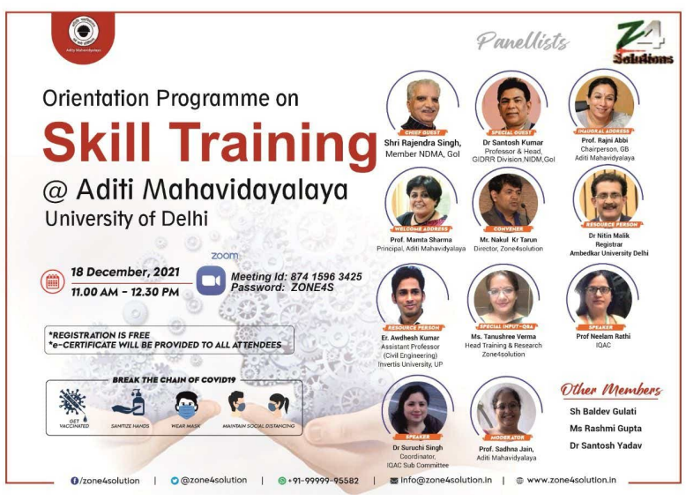
A 30-hour skill development training programme in Disaster Management was organised for students and faculty of Aditi Mahavidyalaya in the year 2021-22. It was intended for students/ teachers/professors of Aditi Mahavidhaya to help build their knowledge, skills and perspectives towards disaster management and emergency response. This helped the concerned stakeholders understand and prepare for an emergency. In this sense, the course covered the following topics.
The Disaster Management Institutionalisation in India
- Identify and list the activities to protect the children and their rights.
- Disaster Management Phases, HRVC assessment
- Fire Safety
- Leadership of Youth for DRR
- Women's issues during COVID-19
- Emergency transportation techniques
- Basic First Aid for the injured
- Non-structural and structural risks, mitigation
- Career Opportunities after graduation, including secretarial services.

Training Method and Techniques
Most skill development programmes followed classroom-led delivery as well as a digital platform. Life-saving skills and emergency response, such as first aid and search & rescue, were also demonstrated in the college campus.
The training was organised to integrate gender-responsive approaches into DRR planning and implementation, ensuring:
- Equal participation of women and men
- Reduction of gender-based vulnerabilities
- Strengthening community resilience through inclusive strategies
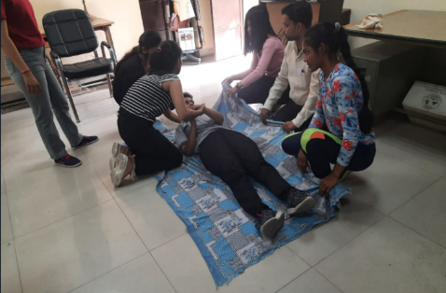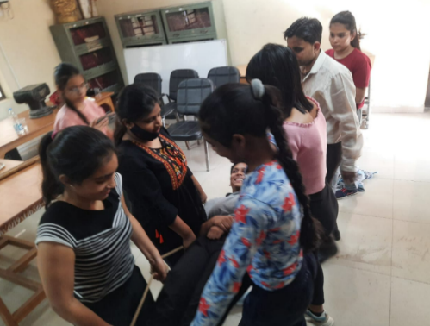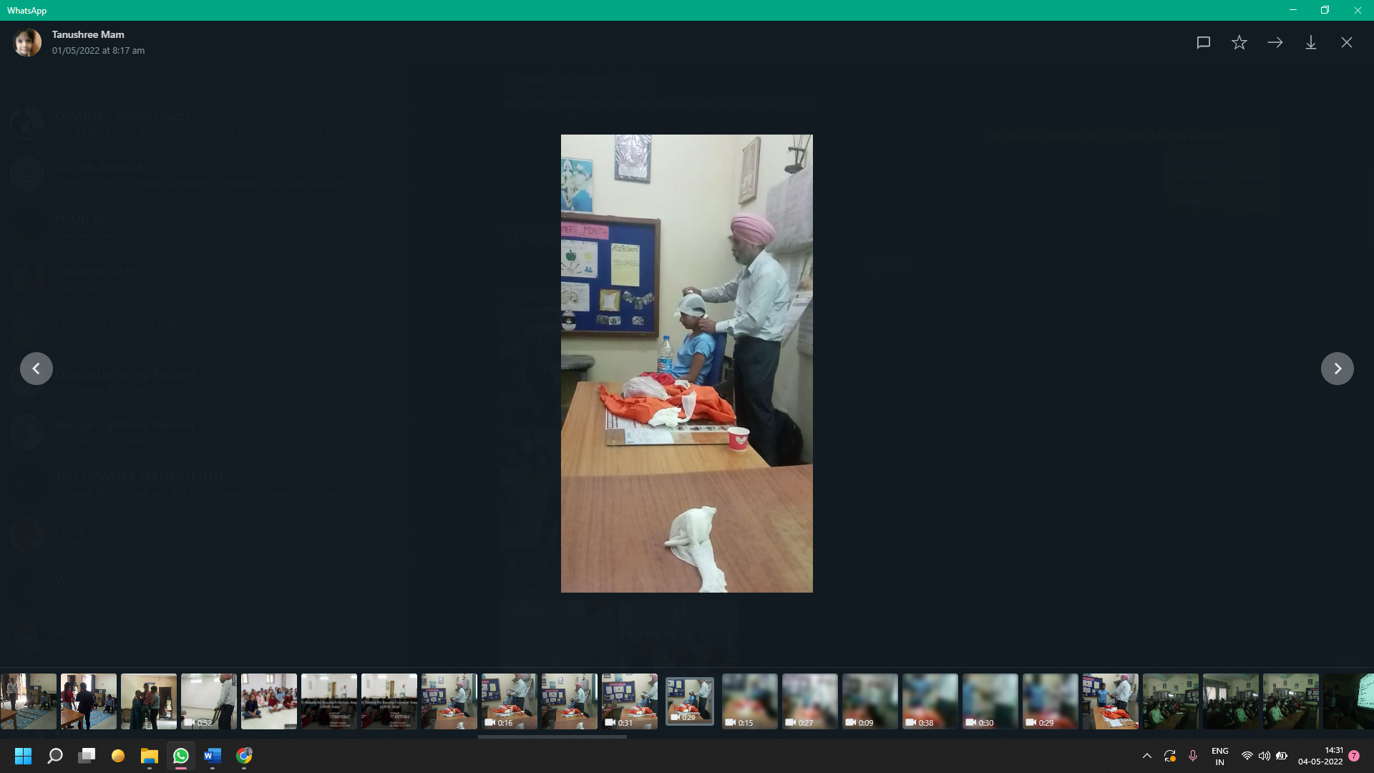

Development of Disaster Management Plan and Mock Drill of Women's Colleges, University of Delhi
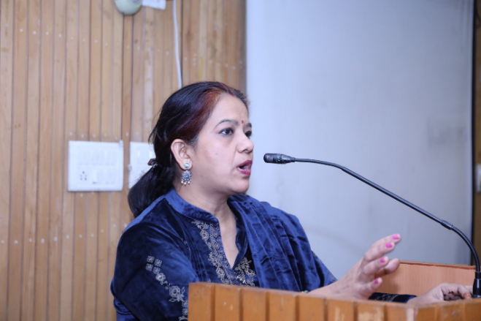
Zone4Solutions is a leading organisation advocating for gender-sensitive Disaster Risk Reduction (DRR) and promoting communities as active partners in preparedness. It emphasises that women, who are often marginalised in disaster planning, must be equipped with the knowledge, skills, and confidence to respond effectively and safeguard their families and communities. The organisation also recognises the untapped potential of young women and girls, whose energy, leadership, and innovative ideas can significantly strengthen gender-responsive DRR.
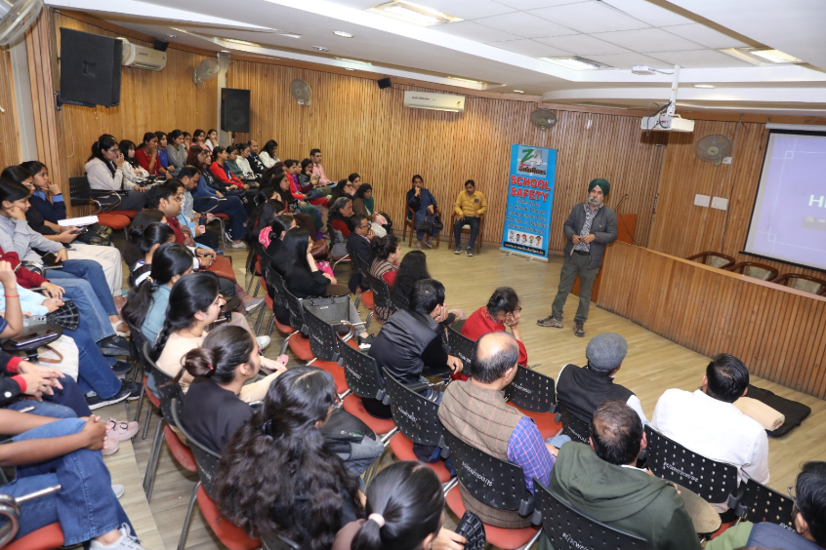
In this context, educational institutions play a critical role. Zone4Solutions has actively engaged colleges and universities to promote gender-centric disaster preparedness. As part of this initiative, the organization developed Disaster Management Plans for three women’s colleges under the University of Delhi, Bharati College, Aditi Mahavidyalaya, and Maitreyi College, through a collaborative and participatory approach. These interventions, combined with training and mock drills, have helped students feel empowered, capable, and confident in their ability to respond swiftly and appropriately during emergencies, thereby strengthening overall institutional and community resilience. 500 plus students, faculty, and other stakeholders were oriented and trained in DRR. During this process, the following activities of Gender Mainstreaming in DRR were considered:
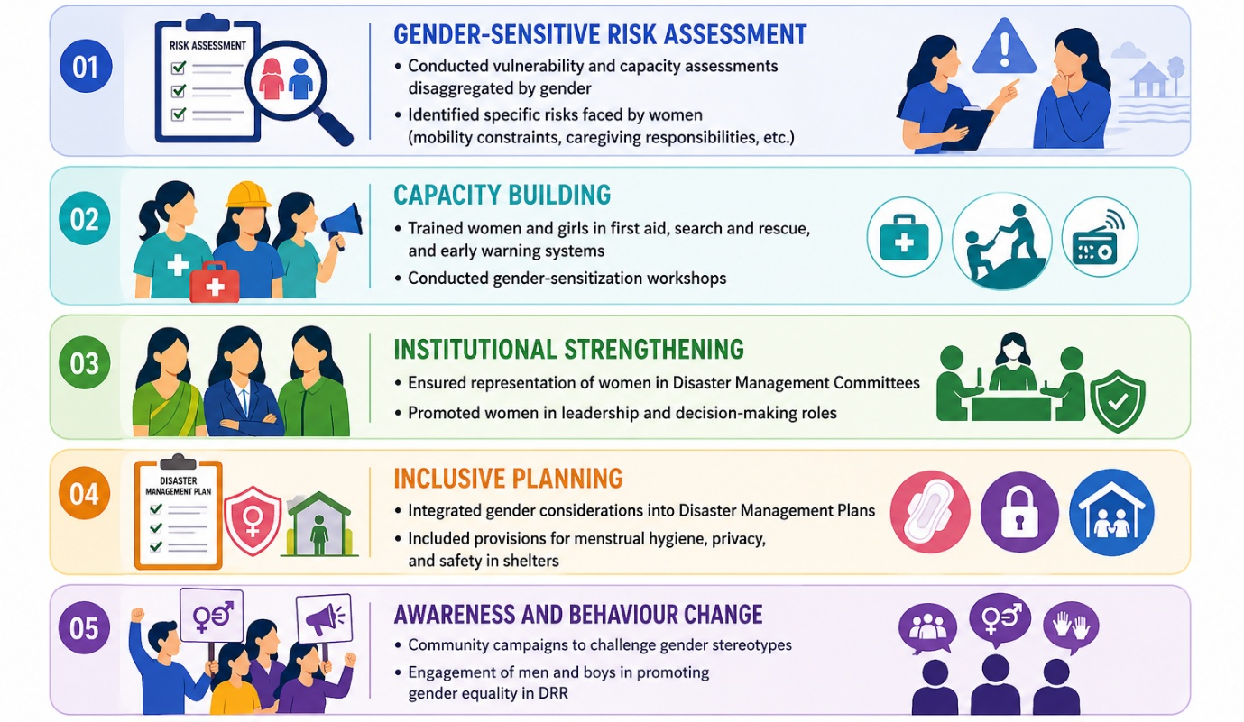

Key Outcomes of Gender Mainstreaming in DRR
They regarded the session as very informative and appreciated the diverse issues covered by the key speakers. It was widely acknowledged that women have specific needs during disasters and hence should be included in decision-making processes to ensure that their needs are catered for. Women’s participation in decision-making and as community leaders is enshrined in international human rights policies and frameworks. However, participants highlighted that it is not enough to recruit women leaders and assume they will address women’s specific needs, as they may not have an understanding of the particular context. Rather, it is necessary to create and adhere to policies that advocate the participation of disaster-affected women in programme design. They also requested to organise more such webinars and events focusing on women empowerment and DRR, Leason Learnt, best practices, and many more.
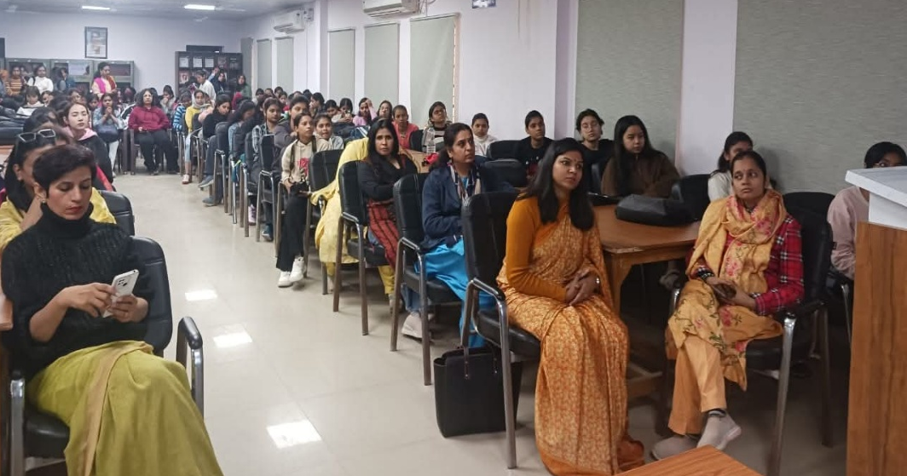

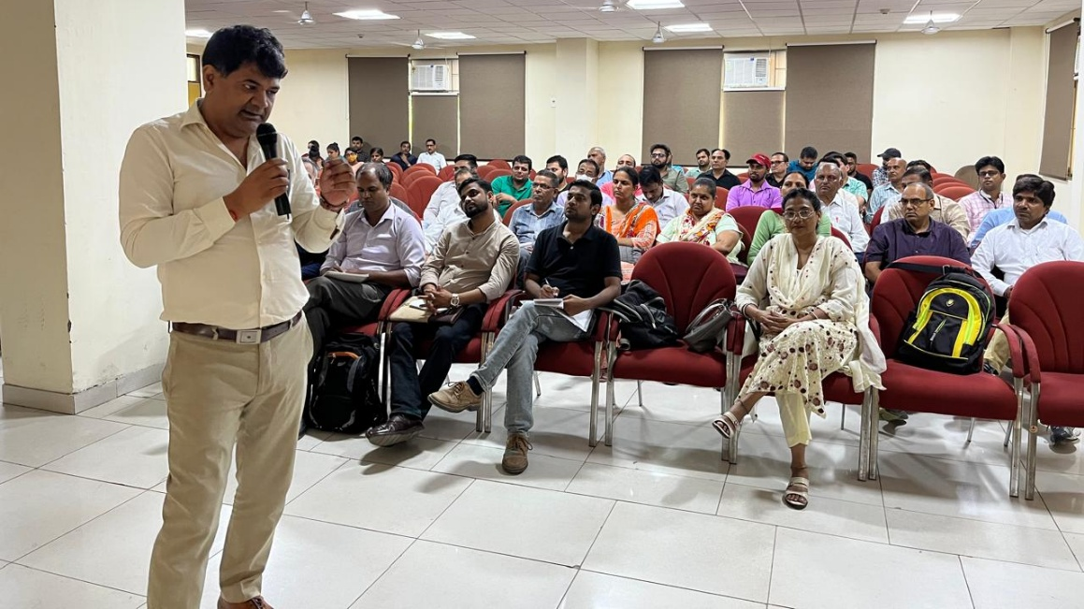

Key outcomes of this initiative are:
- Reduced Gender-Differentiated Vulnerabilities:
Addressing resource constraints and restrictive gender norms helps minimize unequal disaster impacts on women and girls.
- Context-Specific Risk Understanding:
Recognising that gender disadvantage does not uniformly translate into worse disaster outcomes enables more targeted and evidence-based interventions.
- Improved Access to Resources and Information:
Enhanced access for women to early warning systems, safe shelters, financial services (including bank accounts), and stable livelihoods strengthens preparedness, response, and coping capacities.
- Strengthened Role of Women as Change Agents:
Increased recognition of women’s contributions in disaster preparedness, response, and recovery leads to more effective and inclusive DRR outcomes.
- Inclusive and Resilient Recovery Processes:
Post-disaster recovery is leveraged as an opportunity to “build back better” by addressing structural inequalities and empowering women.
- Enhanced Women’s Leadership in Climate Adaptation:
  - Strengthened knowledge and capacity for gender-sensitive climate adaptation and DRR
  - Improved leadership skills among women and adolescent girls to drive resilience-building initiatives across sectors and communities
- Promotion of Gender-Responsive Disaster Risk Financing:
Increased focus on inclusive financial mechanisms ensures that women, particularly in developing countries, can access and benefit from risk financing and protection instruments.

Lessons Learned and Recommendations
- Gender mainstreaming must be integrated from the planning stage, not added later
- Community engagement is critical for shifting social norms
- Capacity building should target both women and men
- Policy support and institutional commitment are essential
- Institutionalize gender-responsive DRR policies and frameworks
- Ensure dedicated budgets for gender inclusion
- Strengthen data systems with gender-disaggregated indicators
- Promote women’s leadership in disaster governance
- Integrate gender into school safety and community awareness programmes

Conclusion
Gender mainstreaming is a concept that is easy to agree on but difficult to implement or follow, and the same happens when it comes to mainstreaming gender perspective in Disaster Risk Reduction policy plan and action. Thus, in order to achieve sustainable development, disaster resilience may be built in both men and women. It is important to institutionalize gender sensitive risk assessments, an early warning system and use gender-sensitive indicators to monitor gender mainstreaming in progress. Gender mainstreaming emphasised developing an increased understanding of gender concerns and developing government capacity. This is to address gender issues and integrate gender perspectives into DRR legislations, policies and programmes for creating sustainable community resilience.

*****

References
- Amin S., Goldstein M., ed. Data against Natural Disasters: Establishing Effective Sysytems for Relief, Recovery and Reconstruction. Washington, DC: The World Bank (2008).
- Bradshaw, S. (2004). Socio-economic impacts of natural disaster: a gender analysis. Sustainable development and human settlement division. Santiago: Women and Development unit.
- Byrne, B. & Baden, S. (1995). Gender, emergencies and humanitarian assistance. Bridge development-gender. Institute of Development Studies.
- Dimitrijevics, A. (2007). Mainstreaming gender into disaster recovery and reconstruction. Washington, DC: World Bank Institute.
- The National Disaster Management Plan, 2019.
- Proceedings of Asian Ministerial Conference on Disaster Risk Reduction (AMCDRR) 2016. 13. The National Policy on Disaster Management, 2009.
- Sinha, A.K. Gujarat earthquake (2010) Asian Disaster Reduction Center (2001).
- UNISDR, UNDP and IUCN (2009). Making disaster Risk Reduction Gender Sensitive Policy and Practical Guidelines
- https://zone4solution.com/wp-content/uploads/2025/11/Report-of-Aditi-Mahavidhyalaya-_1_.pdf.
- https://zone4solution.com/wp-content/uploads/2025/11/Report_IWD24322-_1_.pdf.

